Are You Really a Christian or a Brother Fly
November 30th, 2021

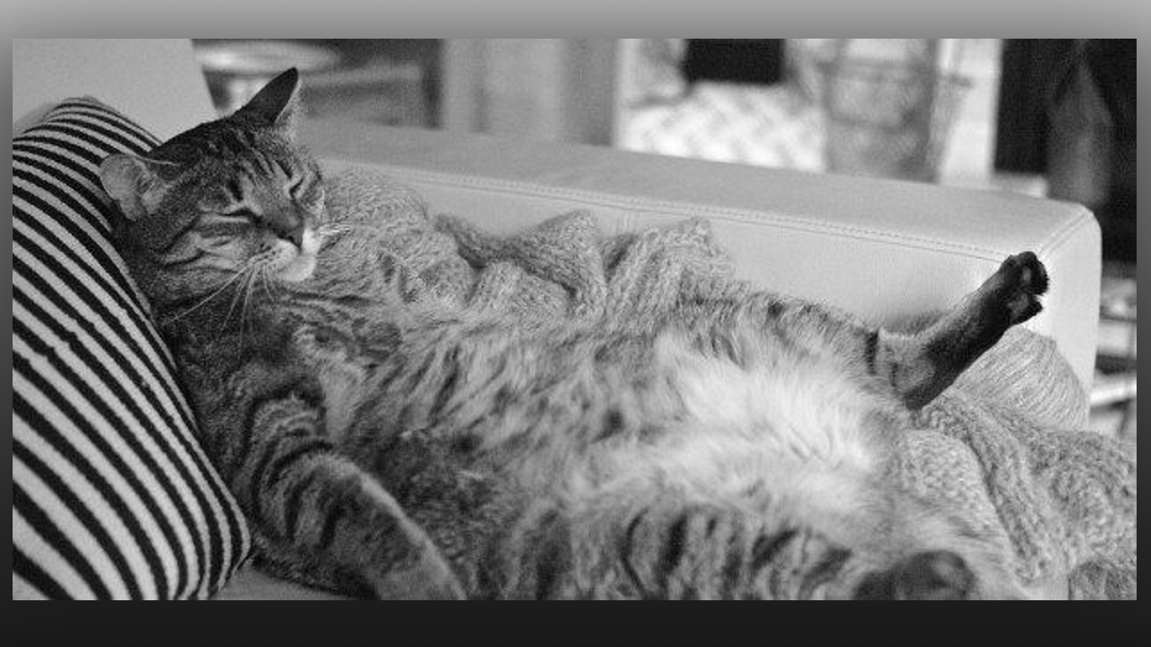
Direct us, Lord, in all our service with Your most gracious favor. Bless us with minds to think, hearts to love and hands to serve You and one another in all things. Amen.

In the early days of the Franciscan Order, when the brothers lived at Rivo Torto, there was a brother who prayed little and did no work, who never went begging, for he was ashamed, but he ate well. Considering his behavior, Blessed Saint Francis of Assisi was warned by the Holy Spirit that this brother was a sensual man. One day he said to him: "Go your way, Brother Fly, for you wish to eat the fruit of the labor of your brothers, while you remain idle in the vineyard of God. You resemble Brother Drone who gathers nothing, does no work, but eats the fruit of the activity of the working bees." He left without asking for forgiveness, for he was a sensual man.

Mother Clare began, “LORD, please speak to me.”

Jesus began speaking, “You have to take control of your flock and bring them up to speed. I just gave you a Rhema that covers My grievances with some who are reluctant to join in the work. A community and a flock are like a family, and everyone in the family has work to do. That’s what makes a family so special, it is a cooperative venture.

“But some are still children, adults in age but children in behavior. They do not know how to give of themselves let alone give until it hurts. As a mother, you have to train them Clare. They are precious but missing a few important qualities. You were an only child, and you were selfish. You can still be selfish, but you have learned to serve. Some see themselves as being exempt from serving in the menial tasks of a day. They are not following My example. I worked very hard at My carpentry and supported My Mother. Not too many think about that when they think of our household. I worked hard in My village. People knew they could count on Me to repair their plow so they could get on with the business of farming. My Mother never worried about having something to eat because I was industrious and did well with My work.

“But here you have a mixture of people. Some are very immature and do not see that they have a part to play beyond praying. Some are older and tired from working in the world, and they see themselves as retired. But I say to you, if you have given Me your life, there is no retirement. You will always be doing something for the kingdom, even if it is only feeding the ministers or helping to clean up after them.

“In My kingdom, everyone IS their brother’s keeper. No one chosen by Me to work in My kingdom is lazy. They do not last if they are not willing to give their all. Each will be rewarded for the good they did, and each will be punished for the good they failed to do. Some will be rejected because they have chosen to serve themselves and let those around them go hungry. I mean this not only about sharing food, but about sharing in the daily chores it takes to provide for everyone.

“My people, I did not come to be served, but to serve. If you have taken on the name, “Christian” you must resemble Me. I was always looking out for My Brothers and the littlest of people with real needs that they had no means of supplying for themselves. Many times, we gave out of our scanty resources to a poor mother or widow. Many times, I helped during the harvest when everyone was working, many times I took care of the needs of a poor neighbor.

“The Scriptures say, “He went about doing good.” Acts 10:38. There it mentions that I healed and cast out demons. Do you suppose that’s all I did? There was a scene from the series the Chosen, that shows My disciples plowing a field for a poor robber. Do you think I asked My brothers to do the dirty work while I sat around and observed? Far be it from Me to give such a poor example, I worked alongside of them as one of them, not as a ruler would lord it over them, but as a humble brother just the same as them. Did I expect them to wash My feet? No, I showed the right example by washing their feet.

“Let Me put it to you plainly. If you will not serve on earth, neither will you serve in Heaven. Those who go to Heaven are servants of all men. There is no job too lowly for them to do. They are souls who have duplicated My way of life. They have learned the secret of holiness, pouring out their lives for the sake of others. Some have painted great works of art and been thought well of for their talent, but they still went to Hell. Even the ones who painted holy images for churches, some of them went to Hell. You ask, “How could that be?” It is very simple, everything they did was for themselves. They did nothing for others. They did not share their bread with widows, they did not help a poor mother who needed medication for her child, they did not help a disabled person clean their yard, mow their grass or collect their trash. The art they did was not out of Love for Me, but because they were getting paid well and showing off their talent.

“They thought of themselves as too special to stoop to help others. They felt they were better than others and helping with chores was beneath them. They were not fit for My kingdom because they only served themselves, leaving others around them with many needs. Such as these will be thrown into outer darkness where there will be weeping and wailing and grinding of teeth.

“Do not let it be said of you that you were lazy, difficult to work with, protesting with anger, quitting before the job is finished, or feigning sickness while others were working. These are not qualities of one who calls themselves by My Name, a Christian. Rather look for ways to shoulder your brother’s burdens and relieve him in his necessity. When a soul comes to the community, there is a period of probation to see how well they work with others, whether they are truly praying and growing spiritually, or if they are just treading water and getting by. Are they self-sacrificing or self-serving? Many are called, few are chosen, and even fewer respond the way they should to this great invitation. This community and flock have a proven record of authentic serving souls, the ones that avoided serving and didn’t take responsibility, are no longer here. I have rejected them and sent them back into the world.

“To be a Heart Dweller and community member is a great privilege, because these are souls that are whole heartedly dedicated to Me, and as such there are many graces given to them so they can grow into the full stature of who I called them to be. I have invested in them and they have borne fruit. They have died to their own self will, and chosen instead to bear the yoke of My Will.”

